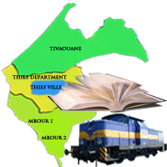
REPUBLIQUE DU SENEGAL
Ministère de l’Education Nationale
Inspection d’Académie de Thiès
Centre Régional de Formation des Personnels de l’Education (CRFPE)
BP: 163 Tel: 339511344
Email: crfpedethies@gmail.com

VISITE DE CLASSE

FICHE ADMINISTRATIVE
Académie : | Année : | Discipline :
Professeur : | Grade : | Ancienneté :
Etablissement : | Date : | Classe : Effectif :$\left\{\begin{aligned}Filles: \\ Garçons:\end{aligned}\right.$
Titre leçon/TD/Correction de devoir :
Professeurs accompagnateurs :
OBSERVATIONS PARTAGEES
……………………………………………………………………………………………. …………………
………………………………………………………………………………………………………………….
………………………………………………………………………………………………………………….
………………………………………………………………………………………………………………….
………………………………………………………………………………………………………………….
………………………………………………………………………………………………………………….
…………………………………………………………………………………………………………………
…………………………………………………………………………………………………………………
…………………………………………………………………………………………………………………
…………………………………………………………………………………………………………………
…………………………………………………………………………………………………………………
RECOMMANDATIONS
…………………………………………………………………………………………………………………
…………………………………………………………………………………………………………………
…………………………………………………………………………………………………………………
………………………………………………………………………………………………………………….
………………………………………………………………………………………………………………….

le Professeur le(s ) formateur(s) le Chef d’établissement

